SUB CODE – OCY751

WASTE WATER TREATMENT

ASSIGNMENT-2

BE CSE IV YEAR

ADNAN AHMED S

311519104005

**WASTE WATER TREATMENT**

***Explain Sand filters , Hydraulics of filtration, High rate and multi media filters,Pressure filters***

**SAND FILTERS**

*What Are Sand Filters?*

Sand filters are constructed beds of sand or other suitable granular material usually two to three feet deep. The filter materials (called media) are contained in a liner made of concrete, plastic, or other impermeable material.

Sand filter units are constructed or assembled onsite by a contractor. Suitable filter must be as clean and uniform in size as possible to allow the wastewater to flow correctly through it.

*Sand Filter Basics*

* There are a few basic operating and design principles common to every type of sand filter system. First, to prevent the filter from clogging, the wastewater must be pre-treated to remove solids and scum. Pre treatment usually takes place in a septic tank or aerobic unit. Screens or filters are sometimes used in the pretreatment tank as an additional step to ensure that no solids carry over to the filter in times of heavy water use.
* After the solids have been removed, a pump sends the wastewater to the filter. Oxygen is introduced into the filter with every dose of wastewater. Oxygen is critical to the biological and chemical treatment processes that take place inside the filter.
* It also is important that wastewater be applied evenly across the filter surface. This is accomplished either by flooding the surface completely with a thin layer of wastewater, or spraying the wastewater evenly over the filter surface.

*How Treatment Occurs?*

Sand filters accomplish much of their treatment through biological processes. Sand filters are home to a variety of organisms, many of which contribute to treatment by consuming organic matter in the wastewater. Bacteria are the most abundant organisms in the filters, and they do most of the work. After the filter has had a chance to mature-usually after approximately two weeks use-a miniature ecological system develops as the organisms multiply and rely on each other to survive.

*Why Consider Sand Filters?*

* Sand filters cost less to construct in rural areas than centralized treatment systems.
* They are energy-efficient
* They have relatively low maintenance requirements but should be serviced by trained technicians.
* They can provide high quality effluent.

*Types of sand filters :*

1. *Rapid sand filters*

* The rapid sand filter do not use biological filtration and depends primarily on sedimentation,physical adsorption.This rapid sand filters has high filtration rate and complete filtration cycle occurs sequentially.Filters must be taken off periodically to back wash automatically.
* There are different types of rapid sand filters based on:
* Bed depth(Eg. Shallow,conventional and deep bed filters)
* Type of filtering medium(Eg. Mono ,dual and multi-medium filters)
* Coagulation,Flocculation and sedimentation occurs in the pre treatment of rapid sand filter. Complete disinfection is must for post treatment.
* It’s installation cost is low but ease of construction is complicated.

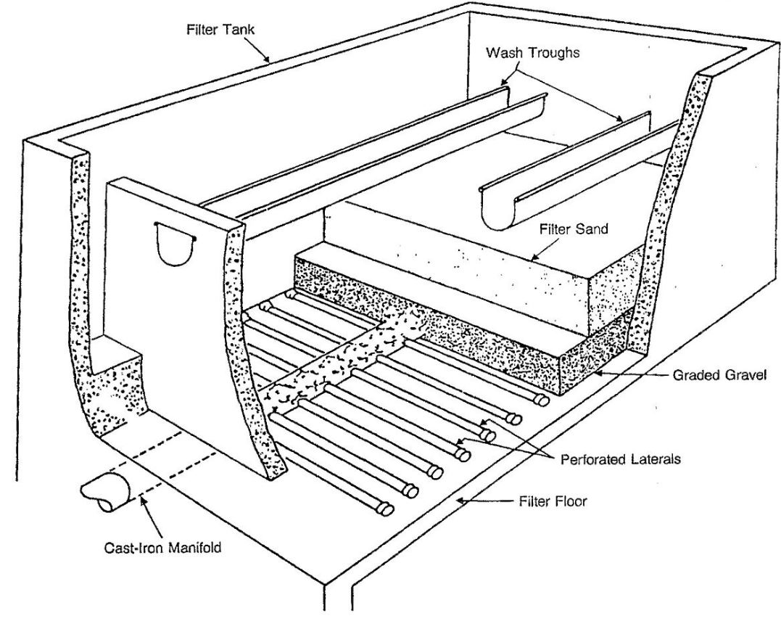

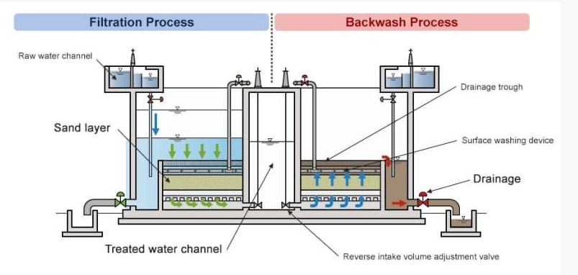

1. *Slow sand filters*

* Slow sand filtration is only used for effluent treatment. These filters can easily eliminate most of the micro-organisms that cause water-borne diseases, including protozoa, bacteria and viruses and used to make water drinkable
* Water passes slowly through a layer of sand 60 to 120 cm thick. As it passes through, several physical and biological processes filter the water and eliminate contaminants.
* Sand filtration systems cannot handle chlorinated water because chlorine has a detrimental effect on the filter’s microbial flora. If water has to be chlorinated, this should only be done after the filtration process, in reservoirs.
* These filters are only suitable for spring water with a low turbidity (low turbidity water), containing little algae and with no unpleasant colour due to contamination. They are not suitable for water with a high content of algae or clay, which tends to clog them. Spring waters rich in nutrients, however, can help the cleaning action of slow sand filters by contributing to their biological composition.

1. *Single Pass Sand Filters*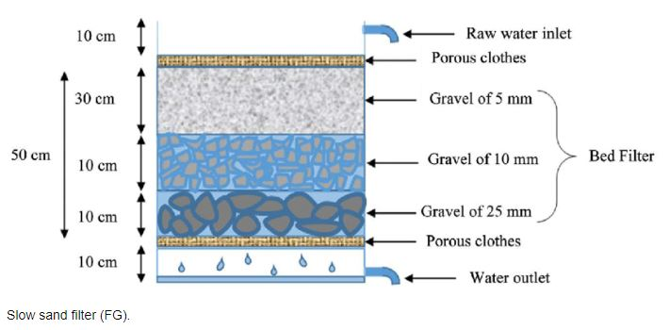

* Single pass sand filters-often called intermittent sand filters-are a practical option for treating wastewater from small communities, residential developments, recreational areas, shopping centers, and institutions.
* Single pass sand filters are at least partially above ground. The entire filter unit is contained in an impermeable liner. Underdrain pipes and a graded layer of washed gravel or crushed rock are placed at the bottom of the filter bed-with the finer gravel on top of the coarser gravel to keep the media grains from washing into the underdrains. The filter media is then placed on top of the layer of fine gravel.

1. *Recirculating Sand Filters*

* Recirculating sand filters reduce odours by ensuring an adequate supply of oxygen to the wastewater. Wastewater flows by gravity from a septic tank to a recirculation tank, which is equipped with a pump and float valves. The wastewater is pumped to the filter when the wastewater reaches a certain level in the tank or in timed doses.
* After receiving treatment in the sand filter, the wastewater collects in underdrains and a portion of it is directed back to the recirculation tank, where it mixes with the septic tank effluent and is recirculated to the sand filter. The remaining sand filter effluent goes directly to further treatment or disposal.

**HYDRAULICS OF FILTRATION**

*What is hydraulic filtration and why do you need it?*

* Hydraulic filters protect our hydraulic system components from damage due to contamination of oils or other hydraulic fluid in use caused by particles. Every minute, approximately one million particles larger than 1 micron (0.001 mm or 1 μm) enter a hydraulic system. These particles can cause damage to hydraulic system components because hydraulic oil is easily contaminated. Thus maintaining a good hydraulic filtration system will increase hydraulic component lifetime.
* The wear of hydraulic system components is dependent on this contamination, and the existence of metal parts in hydraulic system oil (iron and copper are particularly powerful catalysts) accelerates its degradation.
* A hydraulic filtration system includes hydraulic filters to remove dirt and particles on a continuous basis. The performance for every hydraulic filter is measured by its contamination removal efficiency, i.e. high dirt-holding capacities.
* Almost every hydraulic system contains more than one hydraulic filter. The hydraulic filters between pump and actuators are referred to as pressure filters and the hydraulic filters between the actuators and tanks are low pressure or return line filters.

*Basic hydraulic filter components*

* *Filter head:* The ported casting that fluid flow both enters and exits the filter from. Additionally, it can also serve as a mounting pad when mounting to a machine.
* *Filter bowl:* The vessel that threads into the filter head and contains and protects the element. This allows dirty fluid to flow evenly around the outside of the element and the clean fluid to exit through the center of the element.
* *Element:* The cartridge that holds the filter media. The element is responsible for trapping contaminates entrained in the system fluid.
* *Bypass valve:* Valve designed to protect the system when the filter becomes overloaded with contaminates.

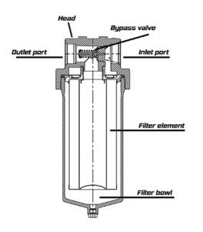

*Parameters for evaluating the performance of hydraulic filter elements*

(a) Efficiency, or filtration ratio, expressed by “Beta” (ß) relates to how well an element removes contamination from fluid. Higher efficiency translates to cleaner oil, better protection of system components, less down time for repair, and lower maintenance costs.

(b) Beta stability is defined as an element’s ability to maintain its expected efficiency as differential pressure across the element increases. Beta stability is important because it relates to how well an element will perform in service over time.

(c) Dirt holding capacity (DHC) is the amount of contamination that an element can trap before it reaches a predetermined terminal differential pressure. DHC has a direct impact on the overall cost of operation.

(d) Pressure drop vs. flow is simply a measure of resistance to fluid flow in a system. It is important to consider the initial pressure drop (Δp) across the filter element (and housing).

*Hydraulic Loading rate*

* Waste-water treatment systems use loading rates as a measure for determining whether the system will have a tendency to clog. Recommended loading rates exist for different types of material such as sands, soil and domestic sewage. Hydraulic loading rates can be used as units of measurement.
* Hydraulic loading rate means the rate at which wastes or wastewaters are discharged to a land disposal or land treatment system, expressed in volume per unit area per unit time or depth of water per unit area per unit.

***Hydraulic loading rate = Design flow (gal/day) / Area (feet ^2).***

* Design flow is the volume of waste water per day.
* A rapid sand filter has an hydraulic loading rate of 5.694 gpd/ft^2

**HIGH RATE AND MULTIMEDIA FILTERS**

*Multimedia Filtration*

* Multimedia filtration refers to a pressure filter vessel which utilizes three or more different media
* Multi-media water filters typically utilize three layers of media for multimedia filtration: anthracite, sand and garnet. These media are often chosen for use in multimedia filters due to the distinct differences in their densities. Anthracite is the lightest filtration media per unit volume, followed by sand, and then garnet.
* The idea behind using media with differing masses is that during backwashing the lightest media with the largest particles (anthracite) will naturally stratify at the top of the filter, while the intermediate sized media (sand) will settle in the middle, and the heaviest media with the smallest particles (garnet) will settle to the bottom.
* This layering of the filtration bed encourages the very largest contaminants to become trapped in the first layer of the filter, with smaller particulates sifting farther down into the lower layers. Trapping contaminants in this manner allows for more efficient turbidity removal and for longer run times between backwash cycles. Multimedia filter that can remove particles down to 10-25 microns.
* Filter backwash may include air scour to help loosen packed dirt in the media bed. When this step is included, it is preceded in the backwash cycle by a “drain down” period for water to be bled out of the filter vessel.
* Flocculants / coagulants may be used upstream of the filter to induce the tiny dirt particles to join together to form particles large enough to be removed by the filter. This process is called “agglomeration” and, with proper chemical dosage, adequate mixing and adequate contact time, it will enable the filter to remove particles below 10 microns in average diameter.
* Multi-media water filters are composed of three filtration media, ordered in decreasing porosity. Because of their multi-layer design, multi-media water filters are able to trap and retain a far larger number of particles than traditional sand filters before backwashing becomes necessary.
* Trapping sediment and particulates throughout the entire depth of the filter bed, allows multi-media water filters to operate for much longer periods of time than conventional sand filters. The process of multimedia filtration produces high quality, filtered water at much faster flow rates than traditional sand filtration.

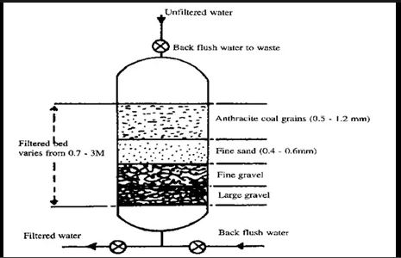

*High Rate Multi-media Filtration*

* Spruce Filter is a high rate multi media filter which removes suspended solids from a wide range of waters at high filtration rates of 25 m/h and above.
* Throughput ranges from 1.5 l/s to 500 l/s per vessel

*Applications:*

* Tertiary filtration of wastewater
* Desalination reverse osmosis pre-treatment
* Industrial process and cooling water filtration and effluent treatment

**PRESSURE FILTERS**

Pressure filters can be used for a variety of conventional filtration media, oxidative media for iron and manganese removal,activated carbon media in any one of several grades and mesh sizes.

*Construction and Operation of Pressure Filters*

* Pressure filters are similar in bed construction to rapid gravity filters, except that they are contained in a steel pressure vessel. Perforated pipes or a steel plate with nozzles are used for collecting the filtered water and for distribution of the washwater and air scour. The steel pressure vessel is cylindrical, arranged horizontally or vertically.
* With a pipe lateral underdrain system, the bottom of the vessel is usually filled with concrete so as to obtain a flat base. In a horizontal vessel, sometimes vertical plates are welded inside to give a rectangular shaped sand bed within the cylinder so that the bed may be washed evenly and there are no areas beneath which air scour and water pipes cannot be placed. More commonly media is placed in the entire vessel such that the depth is equally distributed about the horizontal diameter of the filter.
* The whole of the cylinder is kept filled with water under pressure and at the highest point an air release valve is inserted for the release of trapped air. To avoid having to employ special transportation procedures for large loads the maximum diameter of filters is limited to 3–4 m and the length/height is limited to about 12 m.
* The backwashing of such filters is very similar to that of an open rapid gravity filter. A pipe can be used for the removal of dirty washwater in a vertical filter, for most horizontal filters a single vertical plate located near to one of the dished ends facilitates washwater removal.
* The advantage of pressure filters is that excess raw water pressure is not lost when the filtration process takes place. Pressure filters may be interposed on a pumped or gravity pipeline without a large loss of pressure on the supply.
* Pressure filters suffer from the disadvantage that the state of the bed under backwashing conditions and when the plant is working cannot be directly observed. Every pressure filter is fitted with an open box or dish in the front of it, into which the washwater is turned so that at least any washing out of the sand may be observed and the backwash rate immediately reduced.
* The filtered water usually has enough pressure for backwashing and this is often used so avoiding the need for backwash tanks of pumps. For a filter washed by separate air and water the required rate of application of water is about four times as great as the rate of filtration which is about 5–6 m/h.

*Uses*

Pressure filter is used to:

* Eliminate backwash supply pumps (self-generated backwash)
* Utilize several media configurations
* Maintain system pressure through the treatment process
* Maximize filtration area per footprint (horizontal filters)

*Types*

1. Vertical Pressure Filters

Vertical pressure filters provide granular media filtration in an enclosed pressure vessel. Multiple vessels can be used to allow operating flexibility and backwashing from in-service filters. They are usually found in small to medium sized plants. Individual, parallel operating vessels satisfy redundancy requirements and offer a modular design that is easily expanded with increasing water demand.

Features:

* Improved redundancy with isolated vessels
* Multiple vessels in a single system possible

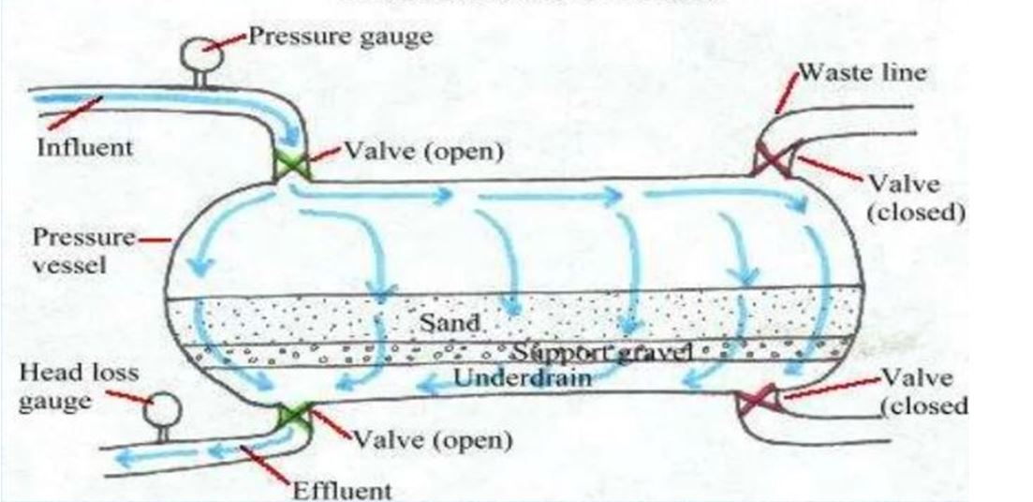

1. Horizontal Pressure Filters

Horizontal Pressure Filters operate like vertical pressure filters, but their horizontal configuration increases its filtration area. Multiple cells can be installed in a single vessel to allow operating flexibility and backwashing from in-service cells. Horizontal Filters

Features:

* Common or isolated underdrain system
* Multiple cells in a single vessel

